# **Name: Abdurrahman Qureshi**

# **Roll No: 242466**

Practical No: 7

Date Of Performance: 19/09/2025

Aim: To demonstrate automation testing of a web application using Selenium.

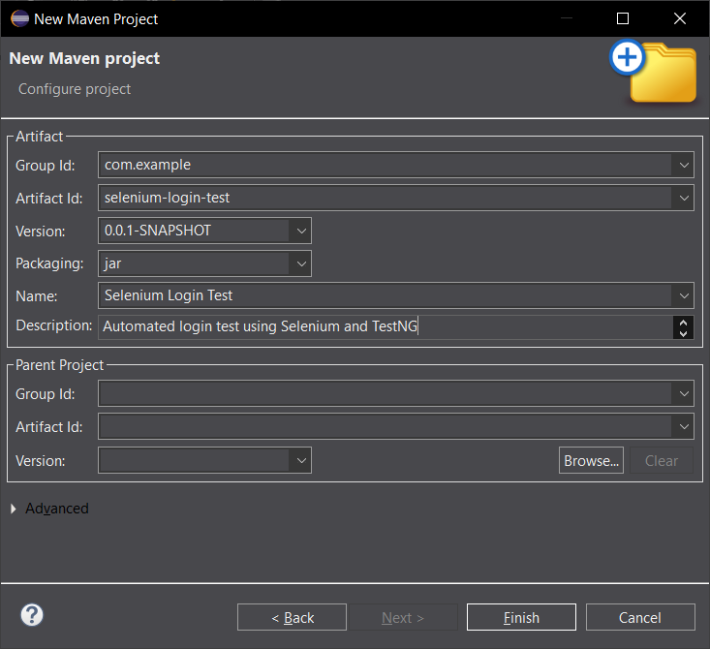

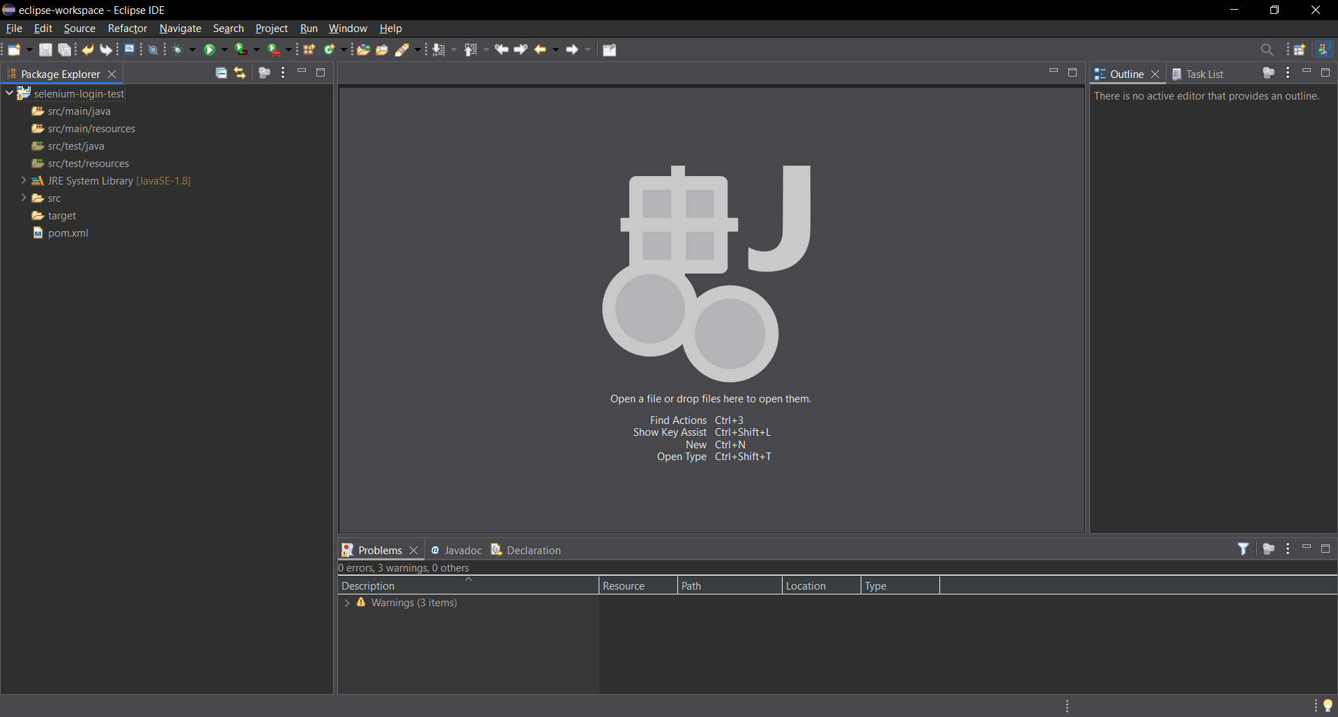

New Maven Project Created

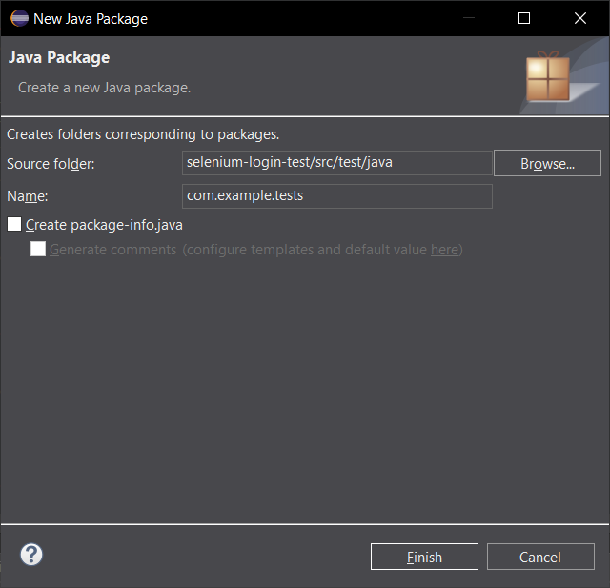

Creating Java Package

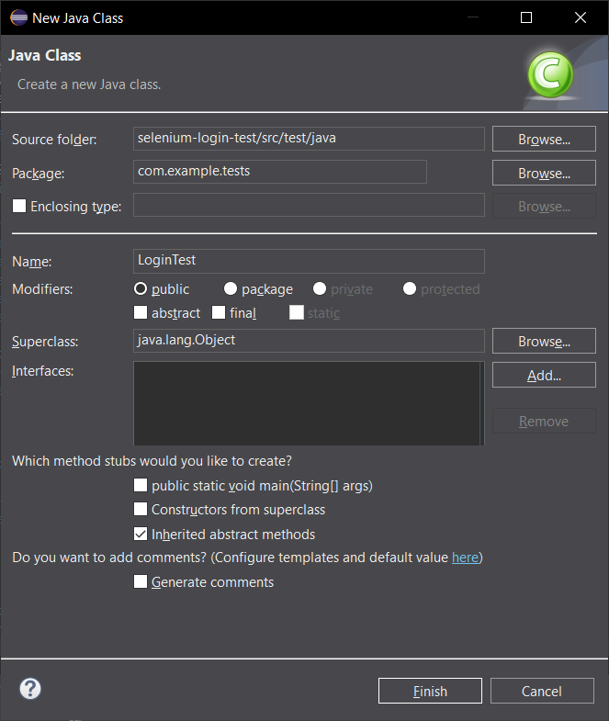

Creating Java File

JAVA CODE:

package com.example.tests;

import org.openqa.selenium.By;

import org.openqa.selenium.WebDriver;

import org.openqa.selenium.WebElement;

import org.openqa.selenium.chrome.ChromeDriver;

import org.testng.Assert;

import org.testng.annotations.BeforeMethod;

import org.testng.annotations.Test;

public class LoginTest {

WebDriver driver;

@BeforeMethod

public void setUp() {

// Initialize ChromeDriver

driver = new ChromeDriver();

driver.manage().window().maximize();

}

@Test

public void testSuccessfulLogin() {

// Navigate to login page (example using demo site)

driver.get("https://www.saucedemo.com/");

// Enter credentials

WebElement username = driver.findElement(By.*id*("user-name"));

WebElement password = driver.findElement(By.*id*("password"));

WebElement loginButton = driver.findElement(By.*id*("login-button"));

username.sendKeys("standard_user");

password.sendKeys("secret_sauce");

try {

Thread.*sleep*(2000); // wait 2 seconds

} catch (InterruptedException e) {

e.printStackTrace();

}

loginButton.click();

// Verify successful login by checking URL or page element

Assert.*assertTrue*(driver.getCurrentUrl().contains("inventory.html"));

}

}

Pom.xml:

<project xmlns="http://maven.apache.org/POM/4.0.0"

xmlns:xsi="http://www.w3.org/2001/XMLSchema-instance"

xsi:schemaLocation="http://maven.apache.org/POM/4.0.0 http://maven.apache.org/xsd/maven-4.0.0.xsd">

<modelVersion>4.0.0</modelVersion>

<groupId>com.example</groupId>

<artifactId>selenium-login-test</artifactId>

<version>0.0.1-SNAPSHOT</version>

<packaging>jar</packaging>

<name>Selenium Login Test</name>

<description>Automated login test using Selenium and TestNG</description>

<properties>

<maven.compiler.source>1.8</maven.compiler.source>

<maven.compiler.target>1.8</maven.compiler.target>

<selenium.version>4.15.0</selenium.version>

<testng.version>7.8.0</testng.version>

</properties>

<dependencies>

<!-- Selenium WebDriver (MAIN DEPENDENCY) -->

<dependency>

<groupId>org.seleniumhq.selenium</groupId>

<artifactId>selenium-java</artifactId>

<version>${selenium.version}</version>

</dependency>

<!-- TestNG Testing Framework -->

<dependency>

<groupId>org.testng</groupId>

<artifactId>testng</artifactId>

<version>${testng.version}</version>

<scope>test</scope>

</dependency>

<!-- Fix SLF4J Warning -->

<dependency>

<groupId>org.slf4j</groupId>

<artifactId>slf4j-simple</artifactId>

<version>2.0.9</version>

</dependency>

</dependencies>

</project>

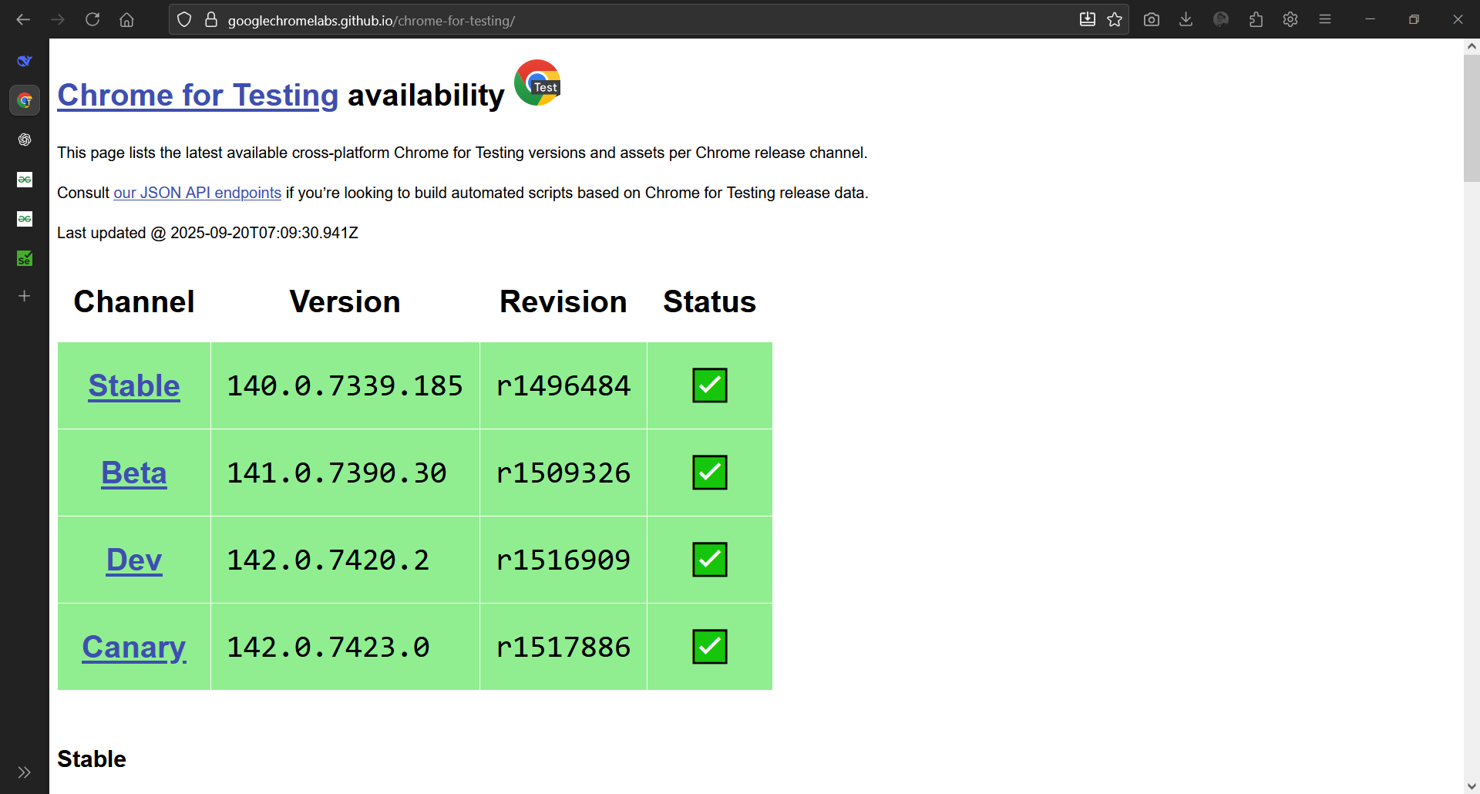

Downloading ChromeDriver zip

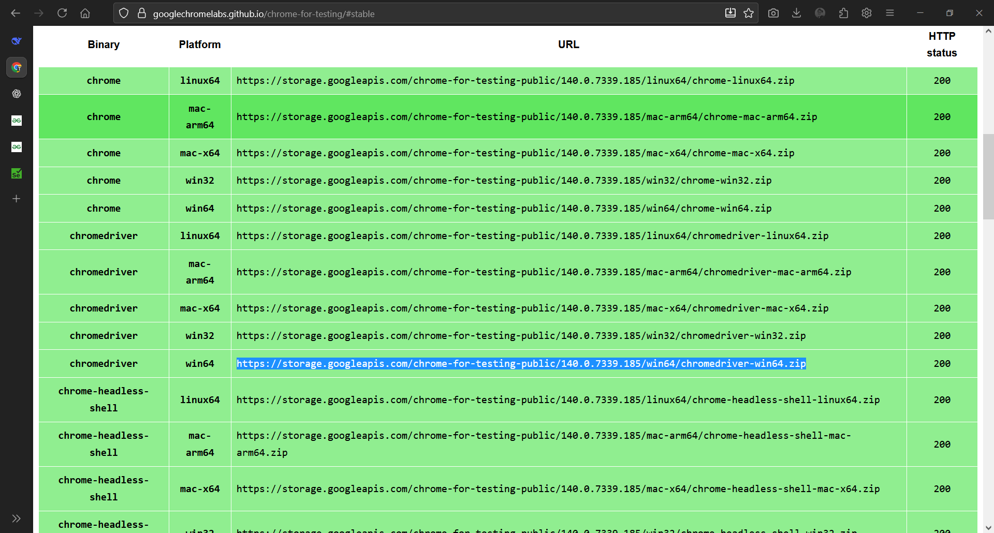

Link for Win64 ChromeDriver

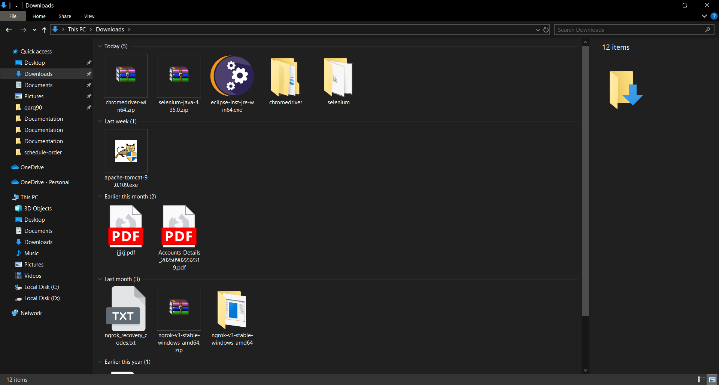

Extracted Win64 ChromeDriver

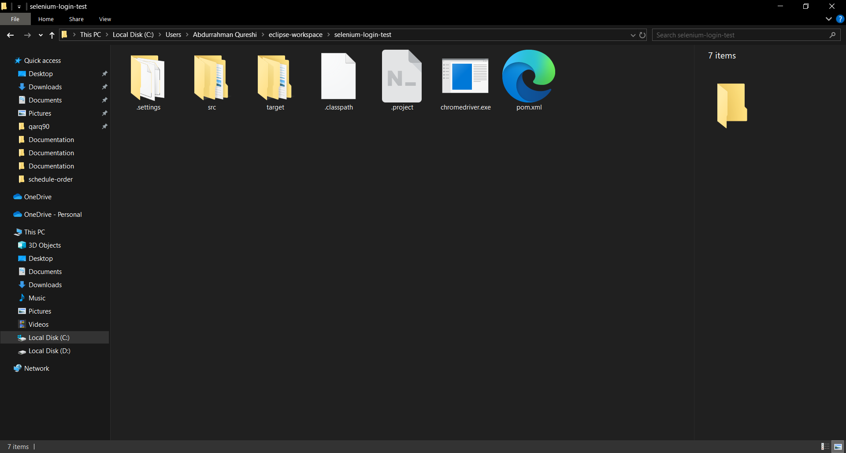

Copied and Pasted ChromeDriver.exe in the Root of the Project

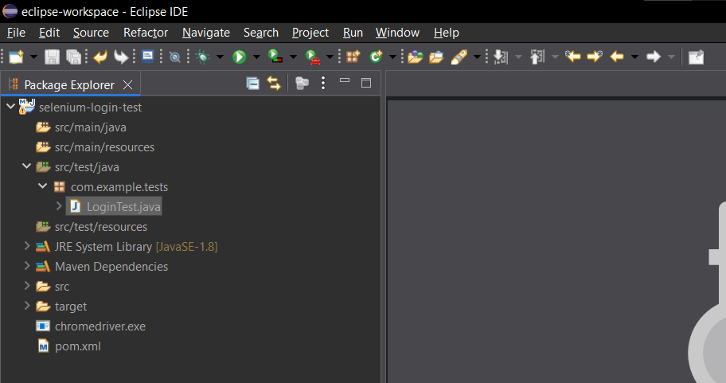

Final Project Structure

OUTPUT:

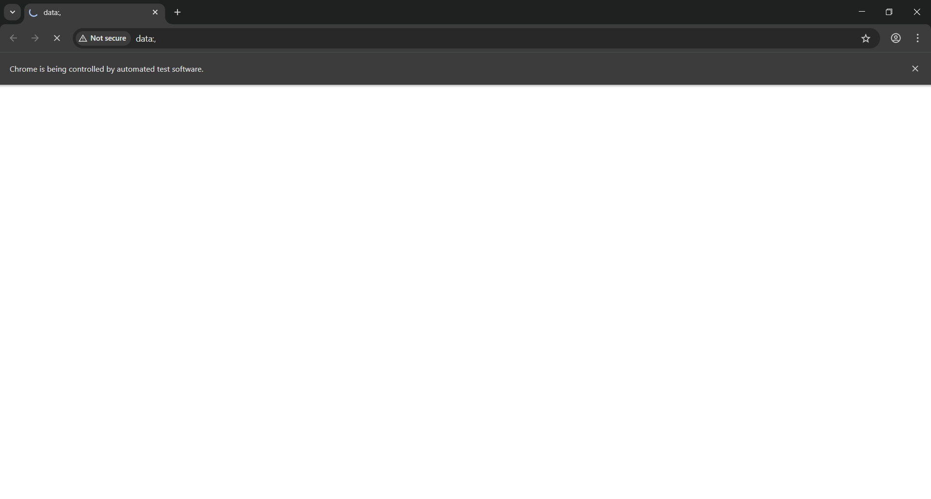

Opening Chrome

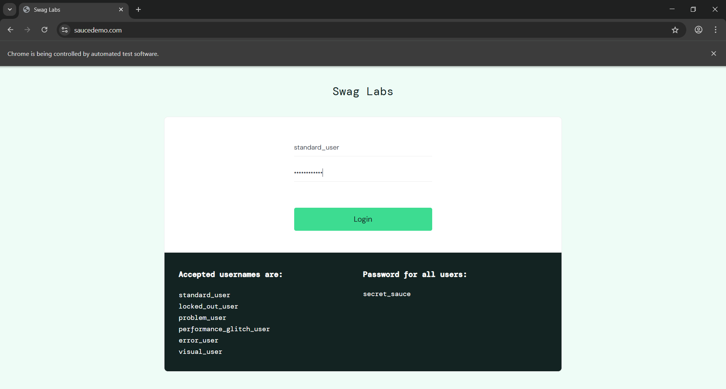

Website Opened (Valid Credentials)

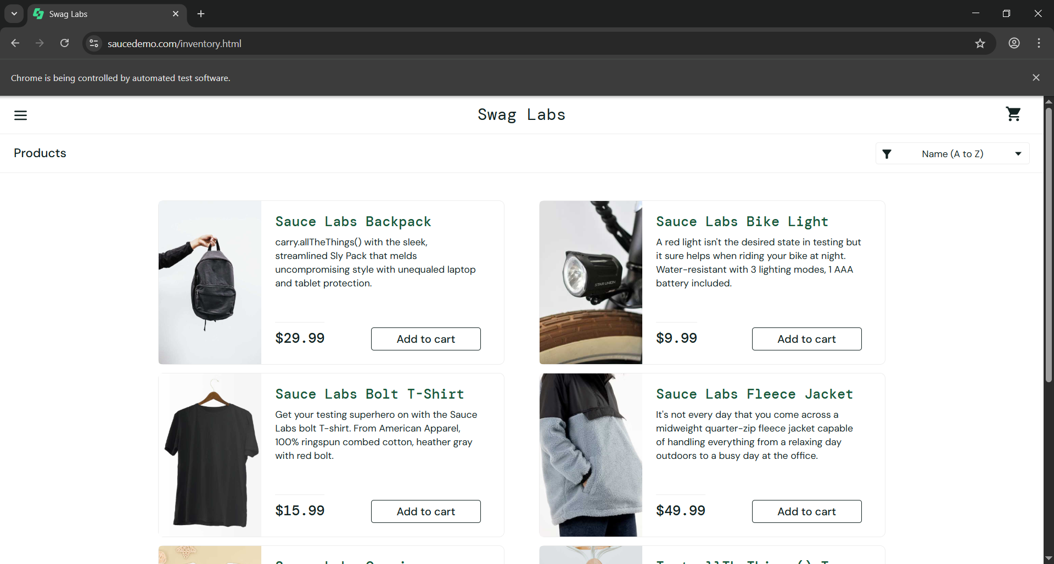

Login Successful due to valid Credentials

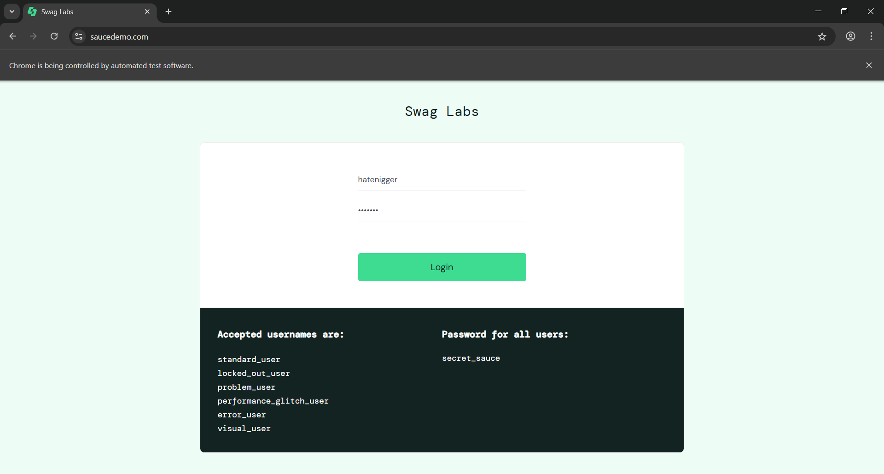

Website Opened (Invalid Credentials)

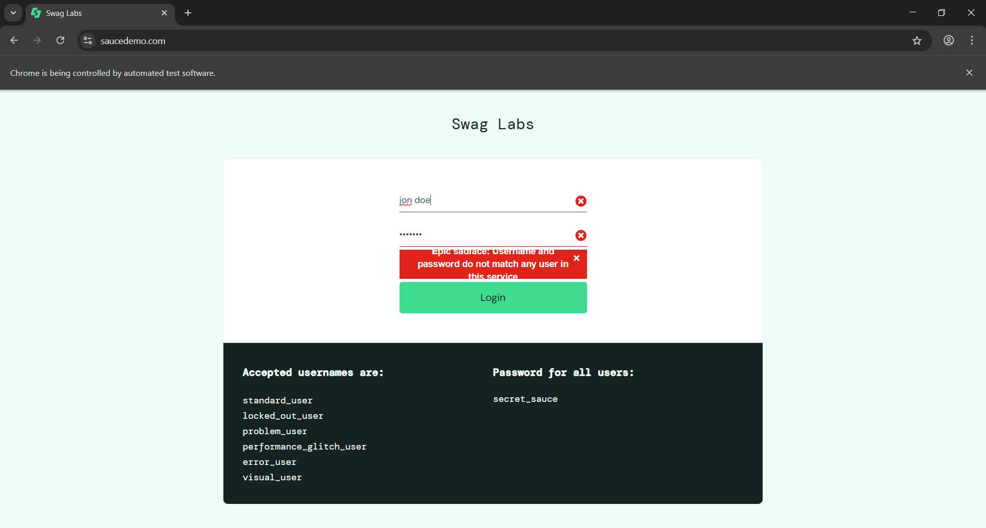

Login Failed due to Invalid Credentials